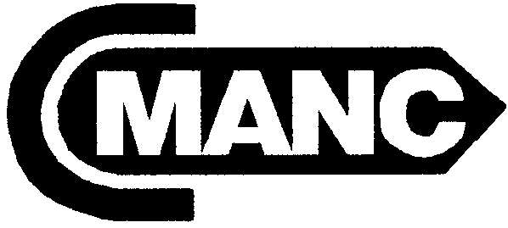 ORGANIZED 1956
CALIFORNIA
MARINE AFFAIRS AND NAVIGATION CONFERENCE
7172 REGIONAL STREET, PMB 299 ~ DUBLIN, CALIFORNIA 94568
PHONE: (925) 828-6215 ~ FAX: (925) 396-6005 ~ E-MAIL: Jim@cmanc.com ~ www.cmanc.com

WINTER MEETING ~SAN PEDRO, CALIFORNIA
Sheraton, Los Angeles Harbor
601 S. Palos Verdes St.
San Pedro, CA
(31) 519-8200

Wednesday, February 9th ~ Friday, February 11th, 2005

Hosted by Port of Los Angeles -- Preliminary Program

Wednesday ~ February 9th
2:30 – 4:30 p.m. Board of Directors Meeting ~ Salon “A”
5:30 – 6:30 p.m. Hosted Reception ~ Los Angeles Maritime Museum

Thursday ~ February 10th

8:30 – 9:00 a.m. Registration & Continental Breakfast

9:00 a.m. Welcome ~ Chair Stacey G. Jones, Senior Director Engineering Development, Port of Los Angeles
9:15 a.m. Washington Briefing ~ Ms. R J Lyerly, Partner, Smith, Esposito, & Lyerly
Sacramento Briefing – Mr. Isaac Kos-Read, Townsend Public Affairs
9:45 a.m. California Coastal Issues, including the California Sediments Master Plan ~ Mr. Brian Baird, Assistant Secretary, California Resources Agency: Mr. George Domurat, Navigation Business Line Manager, South Pacific Division, Corps of Engineers; Ms. Susie Ming, Coastal Studies Group, Los Angeles District, Corps of Engineers; and Mr. Cliff Davenport, SMP Project Manager, California Geological Survey
10:30 a.m. Break
10:45 a.m. Committee Meetings: Communications ~ Environmental ~ Membership Committee ~ Small Craft Advisory Committee
12:00 – 1:30 p.m. Lunch with keynote speaker, MG Don Riley, Director of Civil Works
1:45 – 3:00 p.m. Air Quality Panel, moderated by Mr. Rick Rhoads, Moffatt & Nichol Engineers
Dr. Ralph Appy, Port of Los Angeles, Mr. Thomas Jelenic, Port of Long Beach, Ms. Peggy Taricco, Manager, Technical Analysis Section, California Air Resources Board
3:00 – 3:30 p.m. WRDA: Past and Future ~ Ms. Worth Hager, President, National Waterways Conference
3:30 – 3:45 p.m. Break
3:45 p.m. Committee Meetings: Federal Affairs ~ State Affairs ~ Finance
5:30 p.m. Tour of Vessel Traffic Service System (limited space so sign up early)
6:30 p.m. Dinner Cruise ~ Motor Yacht Spirit
(Departing from Berth 84 South, Maritime Museum Public Dock)
Friday ~ February 11th
8:30 – 9:00 a.m. Registration & Continental Breakfast
9:00 a.m. Committee Reports
10:00 a.m. Break
10:15a.m. CMANC’s Recommendations for FY 2006 Energy and Water Appropriations
11:00 a.m. Panel on Dredging Contracts, moderated by Mr. Mitch White, Manson Construction
Mr. Harry Stewart, The Dutra Group; Mr. Bill Hanson, Great Lakes Dredge & Dock Co.; Mr. Marc Stearns, Manson Construction Co.
12:00 – 1:30 p.m. Lunch with a presentation on Lessons Learned from the Ports of Los Angeles & Oakland
Mr. John Foxworthy, Port of Los Angeles and Mr. Len Cardoza, Port of Oakland
1:30 p.m. Adjourn

