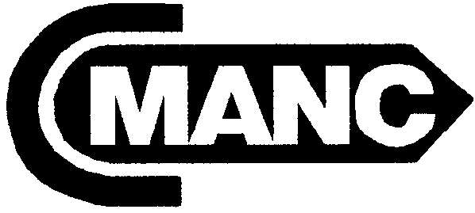 ORGANIZED 1956
CALIFORNIA
MARINE AFFAIRS AND NAVIGATION CONFERENCE
7172 REGIONAL STREET, PMB 299 ~ DUBLIN, CALIFORNIA 94568
PHONE: (925) 828-6215 ~ FAX: (925) 396-6005 ~ E-MAIL: Cmanc2@aol.com ~ www.cmanc.com

SUMMER MEETING ~ SACRAMENTO
Tuesday June 8 - Wednesday June 9, 2004

At the DoubleTree Hotel

2001 Point West Way, Sacramento, CA 95814

Phone: 916/929-8855 ~Fax: 916/924-0719

Agenda

Tuesday ~ June 8

10:00 – 12:00 Board of Directors Meeting ~ Room: Salon D

1:00 -5:00 p.m. Membership Meeting ~ Room: Salon D
California’s Goods Movement Program ~ John Ferrera, Deputy Secretary for Transportation/Highways, Business Transportation and Housing Agency
Army Corps of Engineers Contracting Program ~ Ruth Anne Ijames, Chief of Contracting, Sacramento District
Washington, D.C. Update ~ Del Smith, Smith, Esposito & Lyerly
California’s Resources Agency ~ Crawford Tuttle, Deputy Secretary, California Resources Agency
California’s Environmental Vision ~ James Branham, Undersecretary, California Environmental Protection Agency

5:30 - 7:00 p.m. California Ports & Harbors Reception ~ Room: Salon 1

Wednesday ~ June 9

8:30 – 9:00 a.m. Continental Breakfast ~ Room: Salon D

9:00 – 10:00 a.m. Port Security and Emergency Preparedness Training and Exercises, moderated by Larry Mallon, Esq.: Colonel Jeff Davis, California National Guard; Tom Jensen, Safe Waters; Richard O’Connor, KLI Learning Corporation; and Capt. John Holmes USCG (ret.) Science Applications International Corp.

10:15 – 11:30 Presentations
Ryan Alsop, Director for External Affairs, Office of the Governor
Greg Larson, Chief Deputy Controller, Office of the State Controller
Peter S. Silva, Vice Chair, California Water Resources Control Board

12:00 – 1:30 p.m. Lunch with presentation by Carl Moore, Administrator, Office of Spill Prevention and Response ~ Room: Salon B

1:30 p.m. Adjourn

