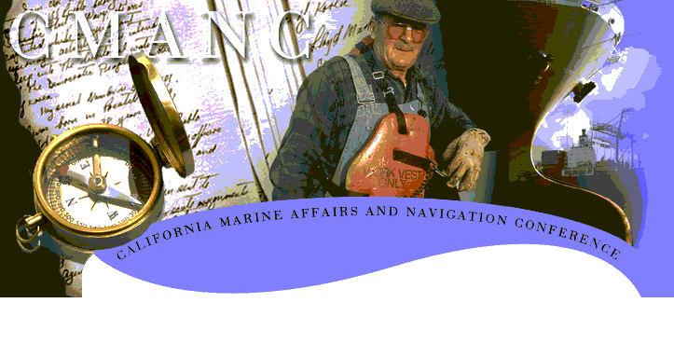
The landmark reforms of the Water Resources Development Act of 1986 established port authorities and other non-Federal sponsors as partners in the water resources development. To further this partnership with the U.S. Army Corps of Engineers, and allow for the efficient and timely project implementation, CMANC encourages the following recommendations for WRDA 2004.

GENERAL POLICY CONSIDERATIONS
►Priority Missions. Ensure full Civil Works missions by reinforcing Congressional intent to continue to give priority to ongoing studies, projects and programs that provide substantial benefits for commercial navigation, flood damage reduction and shore protection.
►Economic Benefit Formulation. Consider new authorities that mandate the Planning, Principles and Guidelines be reviewed and modernized in the area of economic benefit formulation and setting the fleet mix as an interdependent variable during the sensitivity analysis of incremental deepening. Economic benefits other than transportation cost savings should be considered and include environmental aspects, upland disposal, recreation, land creation, job creation, facilities construction, social benefits and United States Customs receipts.
►Marine Transportation System. Support the importance of an integrated Marine Transportation System that provides for a competitive advantage, promotes intermodal links, and addresses regional issues.

SUPPORT OF NEW LEGISLATION
►Credit for In-kind Services. To further the partnership between the U.S. Army Corps of Engineers and the non-federal sponsor, we recommend the inclusion of Credit for In-Kind Work be included in WRDA 2004. This proposal provides an opportunity to better use the capabilities of the non-Federal partner in ways to promote a more efficient and timely project implementation process. The type of in-kind work could be in connection with engineering and design, and construction management.
There have been numerous instances where it makes sense for the sponsor to perform some of the work. Congress recognized this need in WRDA 96 (Section 101(a)(1), SRDA 99 (Section 308,338, and 339) and WRDA 00 (Section 101(a)(2) and 318). Thus, it has become apparent that Congress is willing to have sponsors design and construct portions of a project. However, the examples cited in the previously were each limited to one specific project. A generic provision is needed which will make the design, construction and maintenance phase of a project more efficient by allowing the sponsor to carry out certain features of a project when the Corps and the sponsor agree it makes sense.
It is further recommended that WRDA be amended to allow for credit to be given for work undertaken by the non-Federal sponsor prior to the effective date of the Project Cooperation Agreement.
►Deep Draft Cost Sharing. The current cost sharing formula under WRDA 86, as amended, places a much higher cost burden on non-Federal sponsors of harbor navigation projects that are deeper than 45 feet. West Coast trade projections indicate dramatic increase in Pacific Rim Trade volumes over the next several decades. This burgeoning trade has resulted in the manufacture of larger state-of-the-art container ships, which require deepening of federal channels from their present depths of 50 to 55 feet to accommodate the industry’s shift to the larger mega container vessels. The importance international trade to the U.S. economy supports a greater Federal role in the cost share of navigation channels to maintain the U.S. competition in the world market.
CMANC supports extending the 25% non-federal share established by Section 101 WRDA 86, as amended, from not greater than 45 feet to not greater than 55 feet with the 50% non-Federal share applying to projects with depths in excess of 55 feet and amending same for incremental operation and maintenance costs and utility relocations.
►Regional Sediment Management. Existing flood control channels are impacting harbors and Ports by introducing contaminated sediments and requiring sediment disposal alternatives that place an undo financial burden on the port’s and harbors. We support a regional approach to sediment management practices that allow the U.S. Army Corps to work more effectively with other permitting agencies and extend their reach to allow for maintenance of navigation projects in smart ways that promote more natural movement of sediments to benefit adjacent shorelines and beaches as well as regulatory relief.
CMANC encourages Congress to consider this nation-wide problem and provide higher Federal participation for disposal of contaminated sediments and costs associated with the beneficial use of dredge material for operation and maintenance.
►Expanded Beneficial Uses of Dredged Material. As the cost to dispose of dredge material continues to increase, CMANC supports legislation that would allow for Federal cost sharing for the use of dredge material to support public works projects. However, only if the non-Federal sponsor is included in the final authority along with State or political subdivisions so as not to negatively effect the overall project implementation. Many port and harbor projects are time sensitive and as the non-Federal sponsor we should also have authority over such decisions. Expanded beneficial use would provide an incentive for alternative uses of dredge material that have environmental, economic and social benefits without placing the undo burden of additional costs on the ports and harbors, but also should not be done at the expense of the project schedule.
►Corps of Engineers Lead Permitting Agency Clarification. Congress is urged to direct strengthening of the Memorandum of Understanding designating the Corps as the lead section 404 (Clean Water Act) permitting agency in order to discourage agencies such as EPA, NMFS or USFWS from creating protracted delays. Increased budget operating capability should be provided by Congress to support resulting additional workload.
►Utility Relocations. The federal government should take back its responsibility for utility relocation. Exerting the doctrine of navigation servitude and requiring the removal or relocation of utilities can do this. Or, allow non-Federal sponsors to bring a private action under Section 10 of the Rivers and Harbors Act to require utility relocations.
►Environmental Windows. In any permit issued by the Department of the Army where an “environmental window” is requested, the requester shall use a consensus based process such as the National Academy of Science’s Special Report 262 Process for Setting, Managing and Monitoring Environmental Windows for Dredging Projects in order to justify the request before the condition maybe included in the permit.
►Marine Sanctuaries. Not withstanding any other legislation, a buffer zone, limiting the certification process of the Secretary of Commerce, should be created around federal navigation channels that predate the creation of a National Marine Sanctuary.

