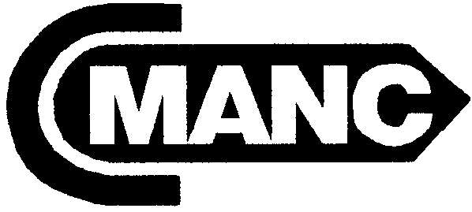 ORGANIZED 1956
CALIFORNIA
MARINE AFFAIRS AND NAVIGATION CONFERENCE
20885 REDWOOD RD., # 345, CASTRO VALLEY, CA 94546
PHONE: (925) 828-6215 ~ FAX: (925) 396-6005 ~ E-MAIL: Staff@cmanc.com ~ www.cmanc.com

SUMMER MEETING ~ SACRAMENTO
Wednesday May 2 – Thursday May 3, 2007

At the Hyatt Regency Sacramento

1209 L Street, Sacramento, CA 95814

Phone: 916/443-1234 ~Fax: 916/321-3099

Agenda

Wednesday May 2nd

10:00 – 12:00 Board of Directors Meeting ~ Golden State Room:

1:00 –3:00 p.m. Membership Meeting ~ Golden State Room:
Mr. David Crane, Special Advisor to the Governor
Mr. Del Smith, Carpi, Clay Smith

3:00 p.m. Walk to Secretary of State’s Office 11th and O Streets

3:30 p.m. Presentations on Federal Transportation & Infrastructure
Mr. Tom Skancke, DOT Revenue Commission Member
Ms. JayEtta Hecker, GAO, Director for Infrastructure

5:30 - 8:00 p.m. California Maritime Transportation Month Reception
Honoring the Port of Los Angeles on their 100th Anniversary
Rotunda, California State Capitol

Thursday May 3rd

8:00 – 9:00 a.m. Breakfast with Speaker, Mr. R. Greg Albright, Deputy Director, CalTrans ~ Golden State Room:

9:00 – 11:30 Membership Meeting ~ Golden State Room:
Mr. James Sandner, U.S. Army, Corps of Engineers
Mr. Joe Sparano, President, Western States Petroleum
Ms. Cynthia Bryant, Governor’s Office of Planning and Research

11:30 a.m. Adjourn

