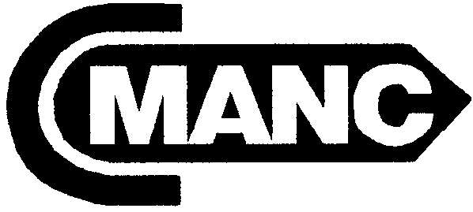 ORGANIZED 1956
CALIFORNIA
MARINE AFFAIRS AND NAVIGATION CONFERENCE
7172 REGIONAL STREET, PMB 299 ~ DUBLIN, CALIFORNIA 94568
PHONE: (925) 828-6215 ~ FAX: (925) 396-6005 ~ E-MAIL: Staff@cmanc.com ~ www.cmanc.com

SUMMER MEETING ~ SACRAMENTO
Wednesday May 3 – Thursday May 4, 2006

At the Hyatt Regency Sacramento

1209 L Street, Sacramento, CA 95814

Phone: 916/443-1234 ~Fax: 916/321-3099

Agenda

Wednesday May 3rd

10:00 – 12:00 Board of Directors Meeting ~ Room: Tahoe

1:00 –4:30 p.m. Membership Meeting ~ Room: Tahoe
Mr. John Barna, Executive Director, California Transportation Commission
Ms. Maureen Gorsen, Director, Dept. of Toxic Substances Control
Mr. Sean Walsh, Director, Office of Planning & Research
Mr. Jim Bourgart, Deputy Secretary for Transportation, BT&H
Mr. Gary Stern, Protected Resources, NOAA Fisheries
Mr. Mike Chrisman, Secretary, Resources Agency

5:30 - 8:00 p.m. California Maritime Transportation Month Reception
Rotunda, California State Capitol

Thursday May 4th

8:30 – 9:00 a.m. Continental Breakfast ~ Room: Regency F

9:00 – 11:30 Membership Meeting ~ Room: Regency F
Ms. R. J. Lyerly, E. Del Smith & Company
Mr. Peter Gatti, Executive Vice President, National Industrial Transportation League
Mr. Paul Gosselin, Chief Deputy Director, Dept. of Pesticide Regulation
Mr. Joe Grindstaff, Director, California Bay Delta Authority

12:00 – 1:30 p.m. Lunch ~ Room: Regency F

1:30 p.m. Adjourn

