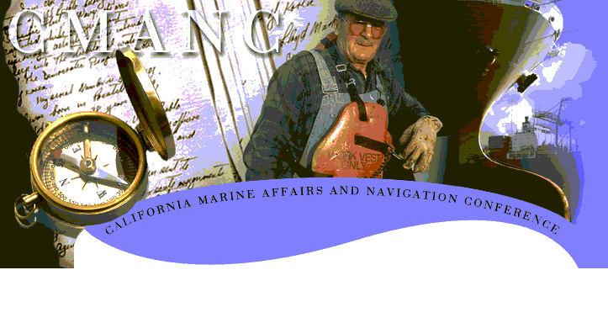

Energy and Water Appropriations
We request Congress provide adequate FY2005 Budget allocations and appropriations for (1) Congressionally authorized Civil Works construction projects and (2) to maintain California Federal ocean entrances and channels.
Corps of Engineers Support
We believe the Corps’ traditional role in the development of the nation’s maritime and flood control projects should remain intact. Any divestiture of this role to other federal agencies would weaken what has become the world’s foremost navigation and water management system. CMANC recommends strengthening of the Corps’ role in these vital national programs through streamlining and refinement of the Corps’ existing systems. CMANC also urges full execution by the Corps of its basic navigation, shore and flood protection mission as well as environmental restoration and recreation authorized by Congress.
WRDA 2004
We urge the passage of a Water Resources Development Act in 2004 to continue the investment in our efficient maritime transportation system to benefit national economic recovery.
TEA-21 Reauthorization
We support reauthorization of TEA-21 so that California ports and harbors can continue to meet the challenges of increased maritime trade by furthering the development of an efficient and flexible multi-modal transportation system.
National Marine Sanctuaries
We support the preservation of the nation’s ocean resources and a balanced decision-making process that will enable sanctuaries and operating harbors to live side-by-side harmoniously. Unilateral authority should not be granted to sanctuaries or their managers. Sanctuary boundaries should not be expanded until outstanding issues are resolved.
Port Security
We support legislation that funds and maintains a safe and secure maritime infrastructure including its transportation system.
Wallop-Breaux Trust Funds
We urge Congress to distribute Wallop-Breaux funds back to the states for use in boating and wildlife restoration programs; and to state maritime infrastructure banks, which can loan or grant funds to appropriate state projects. Wallop-Breaux funds are generated exclusively from federal excise taxes on marine products and fuel. Nearly half of these funds are unallocated.

