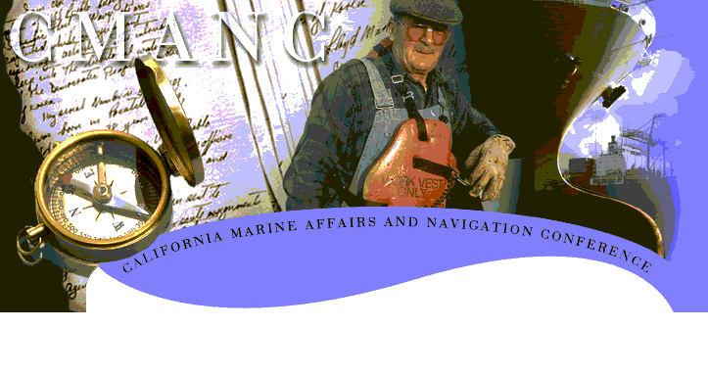

National Economic Benefits of California Ports (2000 dollars)

- Impact on Federal Revenue $10 billion
- Impact on Gross Domestic Product $57 billion
- Impact on Total Employment 1,626,000 jobs
- Impact on Personal Income $30.5 billion

The federal government funds channel maintenance dredging through collection of an ad valorum tax on cargo known as The Harbor Maintenance Tax. More than $240 million annually of this tax is generated from cargo handled in California’s ports and harbors. Currently, the federal government has not spent $2 billion dollars that it has collected for maintenance purposes.

Not only is dredging paid for by a special tax, each:

- $1.00 of federal O & M investment contributes $812 to GDP
- $1.00 of federal O & M investment contributes $161 to federal revenues
- Each $40.56 of federal O & M investment creates one job

California ports and harbors receive only $56 million for channel maintenance dredging – less than 25% of its $240 million Harbor Tax contributions.

75% of the taxes collected in California do not come back to California!

