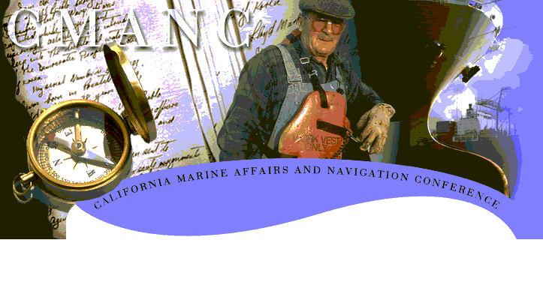

Rick Algert, City of Morro Bay
Dan Allen, Moffatt & Nichol Engineers
Chris Birkelo, Port of Port Hueneme
Jim Blecha, Port San Luis Harbor District
John Bridley, City of Santa Barbara
Bill Buenger, Port of Port Hueneme
Len Cardoza, Port of Oakland
Jack Castle, Port of Redwood City
Mike Cheney, M. H. Cheney & Associates
Joe, Chesler, L.A. County, Beaches & Harbors
Ron Coale, Port of Stockton
Roy Curless, Port of Humboldt Bay
Tim Dunne, Fugro West
Bill Dutra, The Dutra Group
Jay Elder, Port San Luis Harbor District
Dave Elliott, City of Morro Bay
Brian Foss, Santa Cruz Port District
Ray Fosse, Port of Port Hueneme
Mike Giari, Port of Redwood City
Bill Gilfillan, The Dutra Group
Judy Goff, Central Labor Council of Alameda
Roberta Goulart, Contra Costa County
Peter Grenell, San Mateo Co. Harbor District
Vern Hall, V.E. Hall & Associates
Kim Hall, DD-M Crane & Rigging

Jim Haussener, CMANC
Jess Herrera, Port of Port Hueneme
Lee Hieber, Port of Stockton
David Hull, Port of Humboldt Bay
Ellen Johnck, Bay Planning Coalition
Stacey Jones, Port of Los Angeles
Len Junke, Manson Construction
Bob Kavanaugh, Port of Stockton
Lyn Krieger, Ventura County Harbor Dept.
Rod Lundin, DMJM+Harris
R J Lyerly, Smith, Esposito & Lyerly
Larry Mallon, Moss Landing Harbor District
Denise Maurer, DD-M Crane & Rigging
Henry McKay, Port of Stockton
Richard Parsons, Ventura Port District
Oscar Peña, Ventura Port District
Rick Rhoads, Moffatt & Nichol Engineers
Steve Scheiblauer, City of Monterey
Jerry Serventi, Port of Oakland
Nao Takasugi, Port of Port Hueneme
Bob Ulrich, Han-Padron Associates
Sandy Waddell, Ventura Port District
Mitch White, Manson, Construction
William Yates, City of Morro Bay

